Institute of Business Administration, Karachi
Department of Computer Science
Spring 23, Midterm Exam
March 07, 2023, 15:00 – 17:00
Course Code: CSE 141 | Course Name: Introduction to Programming
Student Roll No: |  | Section No:
- Return the question paper.
- In case of any ambiguity, you may make assumptions. But your assumption should not contradict any
statement in the question paper. There are 6 questions and 4 pages only.
- Understanding the paper is part of the exam. The course teacher will not visit the exam room.
- All the answers must be solved according to the sequence given in the question paper otherwise
they will not be graded.
- Be succinct.
Time: 120 minutes. Max Marks: 60 points

Section A (Lab Part): For this section you need to write code on Dev C++ and submit on LMS.
Question # 1: [ Marks: 10 Time:25 minutes]
You are hired to automate an office payroll management. You are asked to create an application that can compute:
- Salary based on the number of hours worked by the employee. The company pays 10 dollars for the first 40 hours worked by each employee and pays half (5 dollars) for all hours worked in excess of 40 hours. You’re given a list of the employees of the company, the number of hours each employee worked last week and the hourly rate of each employee. Your Program must repeatedly ask the number of hours and hourly rate of the worker till -1 is pressed. The Program must terminate when -1 is pressed.
- This company pays its salespeople on a commission basis. The salespeople receive $200 per week plus 9% of their gross sales for that week. For example, a salesperson who sells $5000 worth of goods in a week receives $200 plus 9% of $5000, or a total of $650. Your Program must repeatedly ask the sale till -1 is pressed. The Program must terminate when -1 is pressed.
- Sales tax is collected from buyers and remitted to the government. A retailer has to file a monthly sales tax report which lists the sales for the month and the amount of sales tax collected, at both the county and state levels. calculate the sales tax on the collections and display the county and state taxes. Assume that states have a 4% sales tax and counties have a 5% sales tax. If the month number (1- 12) is not valid the program must terminate. If the month is valid then the program must repeatedly ask for the sale and show computer results.

Expected Output:
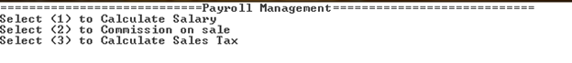
- Calculate Salary
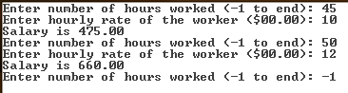

- Calculate Commission on sale.
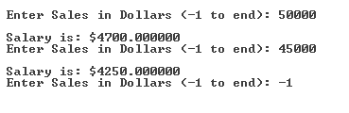
- Calculate Sales Tax
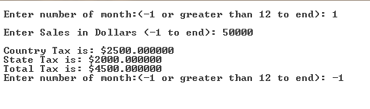
Question # 2: [ Marks: 10 Time:25 minutes]
Take two four-digit numbers from the user. Sum them. Check if the sum is palindrome or even then check the sum of the two number is multiple of 2,3 or 5 else it should print “The number is not multiple of 2,3,5”. If the sum of the user input given is palindrome or odd, then check if it is the multiple of 3 else it should print “The number is not multiple of 3”.
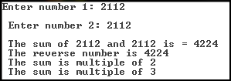
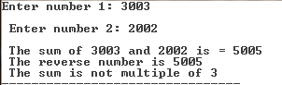
Expected Output:

Section B (Lecture Part): to be solved on answer script

Question# 1: [ Marks: 8 Time:12 minutes]
Correct the errors in the following programs if there are and give the output when these programs are executed:

1.  int main() {  int a = 3, b = 5; int t = a;  a = b; b = t;  printf("%d %d", a, b); return 0;  } | 2.  #include<stdio.h> int main()  {  if((5 && 5) == 5) printf("true"); else printf("false");  return 0;  }
3.  int main()  {  int m ; float n;  m = 4/11; n = 4/11;  printf("%d\n",m);  printf("%f\n",n); return 0;  } | 4.  int main()  {  float p = 13.25, q = 14.5;  if (p = q) {  printf("Think about it!\n");  }  return 0;  }

Question# 2: [16 points, 10 minutes]

Scenario: The IBA ATM machine has biometric security features along with conventional PIN control. If you are IBAian (student or staff), then you have a choice either to use Card + PIN or Card
+ Biometric option. All outsiders can also withdraw cash from our ATM machine; however, they can only use Card + PIN option. Card is blocked by the machine after three consecutive unsuccessful attempts.
Draw a flowchart and problem analysis chart (PAC) of the above scenario with considering all of the following processes or sub processes at least:
- Reading card
- Separating the process for the outsiders and IBAian
- Finger verification process
- Check balance amount
- Card capturing process

Note: Assume all necessary variables and other steps by yourself.

Question # 3 [8 points, 5 minutes]
Write appropriate data types for each of the following items. Provide one line justification for
your choice. Solve this problem on a paper sheet.
a) Age of a person (in years)
b) Speed of light
c) Gender
d) Coordinates of a point
e) Factorial of a number
f) The number of plants in a region
g) Mass of an electron
Question # 4 [8 points, 10 minutes]
A class of ten students took a quiz, The grades (integers in the range 0 to 100) for this quiz are available to you. Determine the class average on the quiz. (write down pseudo code for it and draw the flow chart as well )

Best of Luck

